VISVESVARAYA TECHNOLOGICAL UNIVERSITY
“Jnana Sangama”, Belagavi– 590 018

A Mini Project Report on

“CLAP SWITCH ON AND OFF CIRCUIT”
Submitted in the partial fulfillment of the requirements for the award of degree of

BACHEOR DEGREE
IN
ELECTRICAL & ELECTRONICS ENGINEERING
Submitted by
Ms. AKSHATA TELI 2BL22EE008 Ms.AMRUTA HARADOLLI 2BL22EE010 Ms.JYOTI KAMBAGI 2BL22EE024 Ms.KEERTI PATIL 2BL22EE027
Under the Guidance of
Prof. S. M. BAGI
Assistant Professor, Dept. of EEE


B.L.D.E.A’s
V.P. Dr. P.G. Halakatti College of Engineering & Technology, Vijayapur 586103, Karnataka
Academic Year 2024-25

B.L.D.E.A’s
V.P. Dr. P. G. Halakatti College of Engineering &Technology,
Vijayapur-586103, Karnataka
DEPARTMENT OF ELECTRICAL AND ELECTRONICSENGINEERING
CERTIFICATE
This is to Certify that Ms. AKSHATA TELI, Ms. AMRUTA HARADOLLI
Ms. JYOTI KAMBAGI and Ms. KEERTI PATIL are bonafied students of V. P. Dr. P. G. Halakatti College of Engineering &
Technology, has completed the mini project work entitled “CLAP SWITCH ON AND OFF CIRCUIT” in partial fulfillment for the
award of
Bachelor Degree in Electrical & Electronics Engineering of the
Visvesvaraya Technological University, Belagavi during the year 2024-
2025. It is certified that all corrections/suggestions indicated for Internal Assessment have been incorporated in the report deposited in the departmental library. The mini project report has been approved as it satisfies the academic requirements in respect of project work prescribed for the said degree.

INTERNAL GUIDE HOD PRINCIPLE
Prof. S. M.BAGI Dr. A. S. JADHAV Dr. V. G. SANGAM
Assistant Prof. Dept. of EEE Associate Prof. Dept. of EEE BLDEACET, VIJAYAPURA

Name of the examiners Signature with date
1.
2.

B.L.D.E.A’s
V.P. Dr. P. G. Halakatti College of Engineering &Technology,
Vijayapur-586103, Karnataka
DEPARTMENT OF ELECTRICAL AND ELECTRONICSENGINEERING
DECLARATION
We, Ms. AKSHATA TELI, Ms. AMRUTA HARADOLLI,
Ms. JYOTI KAMBAGI and Ms. KEERTI PATIL, the students of third year
B.E., Electrical and Electronics Engineering, BLDEA’s V.P. Dr. P.G. Halakatti College of Engineering and Technology, hereby declare that the Mini Project work titled “CLAP SWITCH ON AND OFF CIRCUIT” has been
carried out by us and submitted in partial fulfillment of the course requirement for the award of degree in Bachelor of Engineering in Electrical and Electronics of Visvesvaraya Technological University, Belagavi during the academic year
2024-2025. We also declare that we have not submitted this mini project report to any other university for the award of the degree.

NAME USN SIGN

Ms. AKSHATA TELI 2BL22EE008
Ms. AMRUTA HARADOLLI 2BL22EE010
Ms. JYOTI KAMBAGI 2BL22EE024
Ms. KEERTI PATIL 2BL22EE027

ACKNOWLEDGEMENT

The satisfaction and euphoria that accompany the successful completion of any task would be incomplete without the mention of the people who made it possible and whose constant encouragement and guidance crowned my efforts with success.
We express our sincere thanks to our beloved Principal, Dr. V. G. SANGAM for extending his continuous support and providing academic environment.
We wish to thank our Head of the Department Dr. A. S. JADHAV for encouragement and support.
We wish to thank my mini project guides Prof. S.M.BAGI for their encouragement and support without which we could not have moved a single step ahead in the path of our work. Hence we convey my deepest thanks for guiding and correcting various documents of us with attention and care.
We are proud to be part of B.L.D.E.A’s CET family, the institution which stood behind this successful completion of mini project. We owe many thanks to a great many people who helped and supported me for the completion of this report.
We extend special thanks to Beloved Parents and Dear Friends for their continuous encouragement, motivation and blessings without which we would not have reached this stage.
Lastly we would like to thank all those people who have directly or indirectly supported me in carrying out this mini project work.

NAME USN SIGN

Ms. AKSHATA TELI 2BL22EE008
Ms. AMRUTA HARADOLLI 2BL22EE010
Ms. JYOTI KAMBAGI 2BL22EE024
Ms. KEERTI PATIL 2BL22EE027

ABSTRACT

This project presents a novel clap switch circuit that utilizes a 4017 decade counter IC to detect and respond to claps. The circuit incorporates a microphone, a transistor for signal amplification, and an LED to visually indicate the switching action. The system effectively translates sound energy into an electrical signal, which is then processed by the 4017 IC to trigger a switching event. This compact and efficient circuit provides a convenient and innovative method for controlling electronic devices through simple claps, offering potential applications in various fields such as home automation, remote control, and accessibility solutions. The clap switch circuit is a sound-activated control system designed to toggle electrical devices on and off with a clap, a decade counter, as the core component to manage the toggling function. The system incorporates a microphone to capture sound waves, which are then amplified and filtered using transistors and passive components to ensure reliable detection of clap sounds.

The processed signal is fed into the clock input of the 4017 IC, which switches its output states sequentially. This toggling mechanism allows the connected device to turn on or off with each detected clap. The circuit is compact, cost-effective, and easy to construct, making it an ideal choice for beginner-level electronics projects. Applications include home automation, assistive technology for individuals with physical disabilities, and energy-efficient control systems.

TABLE OF CONTENT
CONTENTS PAGE NO.
Declaration.................................................................................................................3 Acknowledgment ....................................................................................................... 4
Abstract 5
Chapter 1 – Introduction 7
Chapter 2 – Background 8
Chapter 3 – Literature Review 9
Chapter 4 – Proposed Method 12
Chapter 5 – Methodology 13
Chapter 6 – Circuit Diagram 19
Chapter 7 – Result and Discussion 23
Chapter 8 – Application 23
Chapter 9 – Advantages and Disadvantages 24
Chapter 10 – Social Impact 25
Chapter 12 – Conclusion 26

CHAPTER 1- INTRODUCTION

1.1 Description

The Clap Switch project introduces a hands-free control mechanism for electronic devices by utilizing sound recognition technology. This innovative system allows users to activate or deactivate devices through the simple act of clapping, providing a convenient and user-friendly interface.

1.2 Objective

The primary objective of the Clap Switch Project is to design and implement a reliable and user-friendly electronic switch system. This involves utilizing sound recognition technology to detect specific acoustic patterns, specifically clapping sounds, as a means of controlling various electronic devices. The project aims to provide an alternative and accessible method for individuals, including those with physical limitations, to interact with their surroundings. The focus is on achieving a seamless integration of technology into daily life, fostering convenience and accessibility.
Specifically, the project aims to:
- Develop a responsive sound sensor capable of detecting distinct clapping patterns.
- Implement a mechanism to control electronic devices, such as lights or fans, based on the detected clapping patterns.
- Optimize the system for efficiency, responsiveness, and minimal false positives
.

CHAPTER 2 BACKGROUND

2.1 Description
The Clap Switch concept is rooted in the broader field of home automation and human computer interaction. Home automation systems aim to enhance the comfort, security, and energy efficiency of living spaces by integrating technology into everyday objects. The Clap Switch, with its emphasis on auditory cues for control, aligns with the growing trend of user-friendly and intuitive interfaces in smart home devices.
The project involves the use of a sound sensor to capture and interpret clapping sounds, a microcontroller to process the input, and a relay to control the connected devices. Understanding the principles behind each component is crucial for the successful implementation of the Clap Switch.

2.2 Motivation
The motivation behind undertaking the Clap Switch project stems from the desire to explore and implement practical applications of technology in everyday life. In a world dominated by technological advancements, the need for innovative solutions to simplify tasks and enhance user experience becomes increasingly apparent. The Clap Switch, as a concept, is fascinating due to its simplicity and potential impact on daily routines. The ability to control electronic devices through sound, in this case, clapping, adds an element of convenience and interactivity to the user's environment.
Beyond the technical aspects, the project is also motivated by the broader goal of fostering an understanding of electronics and automation. As a student pursuing a degree in Computer Science and Engineering, the project provides an opportunity to apply theoretical knowledge to a practical scenario. This hands-on experience is crucial for developing a comprehensive skill set and preparing for future challenges in the field

CHAPTER 3 :LITERATURE REVIEW

A clap switch is a device that can turn on or off an electrical circuit by the sound of a clap. It is a simple and convenient way to control appliances without using physical switches. Clap switches have various applications in home automation, security systems, entertainment devices, and assistive technology for people with disabilities. The basic principle of a clap switch is to use a microphone to capture the sound of a clap and convert it into an electrical signal
. The signal is then amplified
and processed by a circuit that can detect the clap pattern and trigger a relay to switch the load on or off. The circuit may also include a timer, a counter, a memory, or a display to provide additional features and functionality.
There are many different designs and implementations of clap switches, ranging from simple circuits using discrete components to complex systems using microcontrollers and digital signal processing.
Some of the factors that affect the performance and reliability of a clap switch are:
- The sensitivity and frequency response of the microphone
- The noise level and background sounds in the environment
- The amplification and filtering of the signal
- The threshold and algorithm for clap detection
- The power consumption and durability of the circuit
- The user interface and feedback of the device
The following sections review some of the existing literature on clap switch design and development, and highlight the main challenges and opportunities for improvement.

3.1 Clap Switch Using Discrete Components

One of the simplest and most common ways to build a clap switch is to use discrete components such as resistors, capacitors, transistors, diodes, and relays. These components are readily available and inexpensive, and can be easily assembled on a breadboard or a printed circuit board.
The circuit consists of four main stages: a microphone, an amplifier, a clap detector, and a relay driver. The microphone is a piezoelectric or an electret type that converts the sound pressure into a voltage. The amplifier is a transistor or an operational amplifier that boosts the signal level and filters out unwanted frequencies. The clap detector is a Schmitt trigger or a comparator that compares the signal with a reference voltage and generates a logic output. The relay driver is a transistor or a Darlington pair that switches the relay on or off according to the logic output. The relay is a mechanical or a solid-state device that connects or disconnects the load from the power source.
The advantages of this design are its simplicity, low cost, and ease of modification. However, it also has some drawbacks, such as:
- The microphone may pick up other sounds besides claps, such as coughs, knocks, or speech, and cause false triggering or mis operation.
- The amplifier may introduce noise or distortion to the signal, and affect the accuracy and stability of the clap detection.
- The clap detector may not be able to distinguish between single and multiple claps, or different clap patterns, and limit the functionality and flexibility of the device.
- The relay may consume a lot of power, generate heat and noise, and wear out over time.

3.2 Clap Switch Using Microcontroller

Another way to build a clap switch is to use a microcontroller, which is a small and programmable computer that can perform various tasks and functions. A microcontroller can process the signal from the microphone, detect the clap pattern, and control the relay or other output devices.
The circuit consists of three main stages: a microphone, a microcontroller, and a relay driver. The microphone is the same as in the previous design, but the signal is fed directly to the analog input of the microcontroller. The microcontroller is a PIC, an Arduino, or any other suitable type that has an analog-to-digital converter, a timer, and a digital output. The microcontroller converts the analog signal into a digital value, measures the time interval between claps, and compares it with a predefined value. The microcontroller then generates a high or low output to switch the relay on or off. The relay driver is the same as in the previous design, but it is controlled by the digital output of the microcontroller.
The advantages of this design are its versatility, accuracy, and functionality.
The microcontroller can be programmed to perform various tasks and functions, such as:
- Adjusting the sensitivity and frequency range of the microphone
- Filtering and smoothing the signal from the microphone
- Setting the threshold and algorithm for clap detection
- Recognizing different clap patterns and sequences
- Counting the number of claps and displaying it on a LED or LCD
- Setting a time delay or a timeout for the relay
- Providing an audible or visual feedback for the user

However, this design also has some drawbacks, such as:
- The microcontroller may require additional components, such as a crystal oscillator, a voltage regulator, and a programmer, which increase the cost and complexity of the circuit.
- The microcontroller may consume more power than the discrete components, and require a battery or an adapter for operation.
- The microcontroller may be affected by electromagnetic interference or static electricity, and cause malfunction or damage

3.3 Clap Switch Using Digital Signal Processing

A third way to build a clap switch is to use digital signal processing, which is a technique that manipulates and analyzes signals using mathematical operations and algorithms. Digital signal processing can enhance the quality and performance of the clap switch, and provide more features and functionality.
The circuit consists of four main stages: a microphone, an analog-to-digital converter, a digital signal processor, and a relay driver. The microphone is the same as in the previous designs, but the signal is converted into a digital form by the analog-to-digital converter. The analog-to-digital converter is a device that samples the signal at a certain rate and resolution and generates a stream of binary numbers. The digital signal processor is a specialized microcontroller or a dedicated chip that performs various operations and algorithms on the digital signal, such as:
- Filtering and smoothing the signal to remove noise and distortion
- Detecting and measuring the peaks and valleys of the signal to identify claps
- Extracting and analyzing the features and characteristics of the signal, such as frequency, amplitude, duration, and envelope
- Classifying and recognizing the signal based on predefined criteria and models
- Generating and sending a control signal to the relay driver
The relay driver is the same as in the previous designs, but it is controlled by the control signal from the digital signal processor.
The advantages of this design are its high quality, reliability, and intelligence. The digital signal processing can improve the signal-to-noise ratio, reduce false triggering and mis operation, and increase the functionality and flexibility of the device. However, this design also has some drawbacks, such as:
- The analog-to-digital converter and the digital signal processor may require highspeed and high-resolution components, which increase the cost and complexity of the circuit.
- The digital signal processing may require advanced knowledge and skills in mathematics, programming, and algorithm design, which increase the difficulty and time of development.
- The digital signal processing may introduce latency and error to the signal, and affect the responsiveness and accuracy of the device.

CHAPTER 4: PROPOSED METHOD

- The proposed method for implementing the Clap Switch On/Off Circuit involves designing and assembling a compact circuit on a 3.5 x 6 cm PCB board using the following components:

1. Microphone (MIC): Detects the sound of a clap and converts it into an electrical signal.

2. Transistor (BC547/BC548): Amplifies the weak signal from the microphone to a level suitable for further processing.

3. Capacitor (47µF, 25V): Stabilizes and filters the signal to ensure reliable triggering.

4. Resistors: Various resistors (470Ω, 100kΩ, 1MΩ, and 10kΩ) are used
for current control, voltage division, and biasing.

5. IC 4017 with a 16-pin IC holder: A decade counter that toggles its output between HIGH and LOW with each input pulse. This IC is the core of the circuit, controlling the ON/OFF states.

6. LED: Acts as an indicator, showing the current state of the circuit (ON or OFF).

7. 9V Battery and Connector: Powers the circuit.

PCB Design:

The circuit layout is designed to fit within a 3.5 x 6 cm PCB board. Components are arranged compactly to ensure efficient space utilization and reduce interference. Proper soldering and connections ensure stability and durability of the circuit.

This method provides a cost-effective and efficient solution for controlling devices using sound, making it ideal for automation and learning purposes.

CHAPTER 5 : METHODOLOGY
The methodology for designing and implementing the Clap Switch On/Off Circuit involves several steps, from component selection to assembly and testing, as detailed below:

1. Component Selection and Analysis

- IC 4017: Acts as a decade counter, toggling the circuit state based on input signals.

- 47 µF, 25V Capacitor: Filters and stabilizes the input signal.

- BC547/BC548 Transistor: Amplifies the weak signal from the microphone.

- Resistors: Used for current limiting, voltage division, and biasing to ensure proper operation.

- Microphone (MIC): Detects the sound of a clap and generates a small voltage signal.

- LED: Provides visual feedback of the circuit's ON/OFF state.

- 9V Battery and Connector: Powers the entire circuit.

2. Circuit Design

- The design is created to fit a compact PCB of size 3.5 x 6 cm.
- The microphone is connected to the base of the transistor for signal amplification.
- The amplified signal is fed into the IC 4017 to toggle its output state.
- Resistors and capacitors are placed in the circuit to stabilize and regulate signals.

- The output of the IC 4017 is connected to an LED for indication and can also drive other devices via a relay.

3. PCB Layout

- A PCB layout is designed to ensure efficient component placement and minimize signal interference.
- Tracks are routed to maintain proper connections between components.
- The 16-pin IC holder is used for mounting the IC 4017 securely.

4. Assembly

- Components are soldered onto the PCB as per the layout design.
- Proper care is taken to avoid solder bridges or loose connections.
- The LED, microphone, and battery connector are mounted to accessible points for easy operation.

5. Testing
- The assembled circuit is connected to a 9V battery, and the functionality is tested.

- A clap is given near the microphone to check if the LED toggles between ON and OFF states.
- If the circuit fails to operate, connections and components are rechecked.

6. Final Integration

- After successful testing, the circuit is enclosed in a protective casing.
- Proper labeling of input/output points is done for user convenience.
- This methodology ensures a reliable and efficient implementation of the Clap Switch On/Off Circuit, suitable for learning, experimentation, or practical applications.

5.1 Materials and Tools
The materials and tools that we used for our project are listed below:
- Breadboard: A breadboard is a device that allows us to connect electronic components without soldering. It has many holes that are internally connected by metal strips. We used a breadboard to build our clap switch circuit and test its functionality.
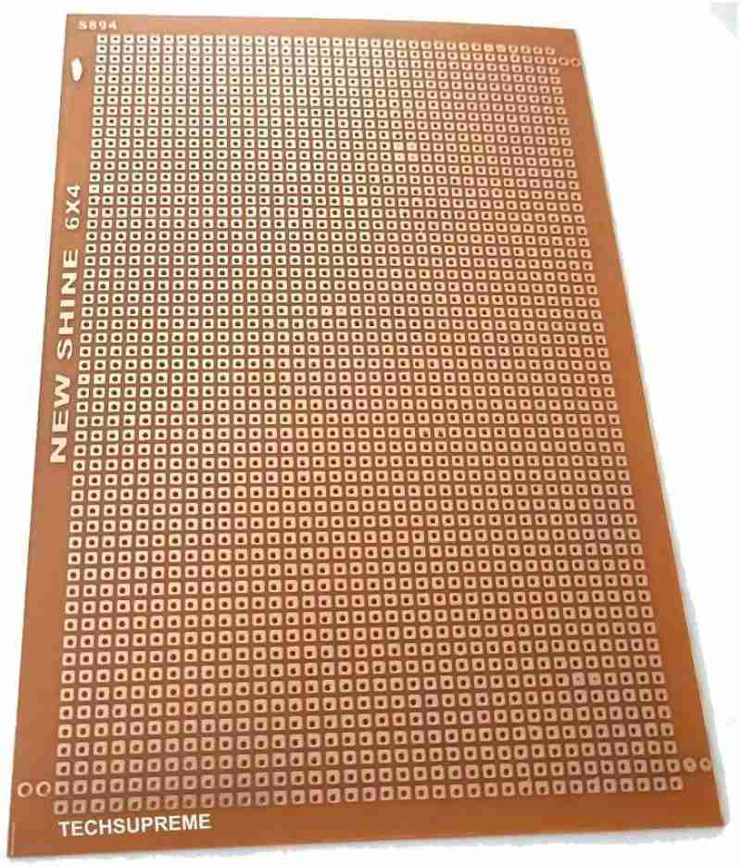

- Microphone: A microphone is a device that converts sound waves into electrical signals. We used a condenser microphone as a sound sensor to capture the clap sound and generate a small voltage.

- 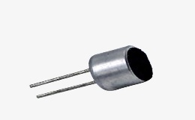

IC 4017: IC 4017 is an integrated circuit that consists of a 5-stage Johnson decade counter with 10 decoded outputs. It can be used to create sequential switching circuits. We used IC 4017 as a clap detector to toggle the output state for each clap sound.

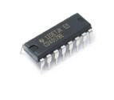

LED: A LED (light-emitting diode) is a device that can emit light when an electric current passes through it. We used a LED to indicate the output state of the IC 4017.
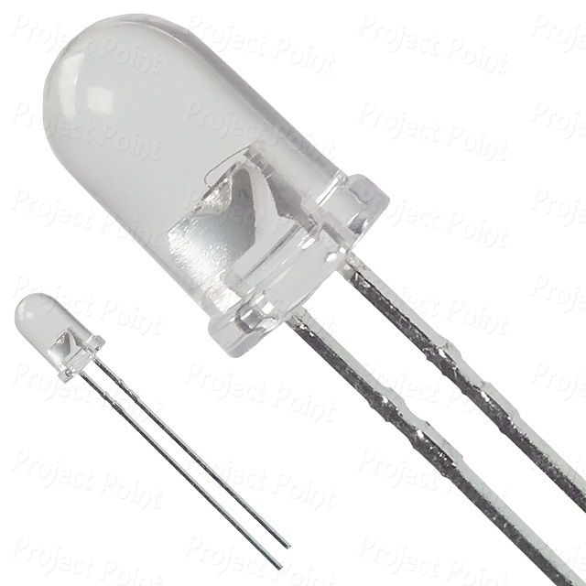

Transistor: A transistor is a device that can amplify or switch electrical signals.

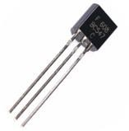

- Capacitor: A capacitor is a device that can store electrical charge. We used two types of capacitors in our circuit: ceramic and electrolytic. Ceramic capacitors are small and have low capacitance values. We used them to filter out high-frequency noise from the signal. Electrolytic capacitors are large and have high capacitance values. We used them to smooth out the signal and provide a time delay for the relay.
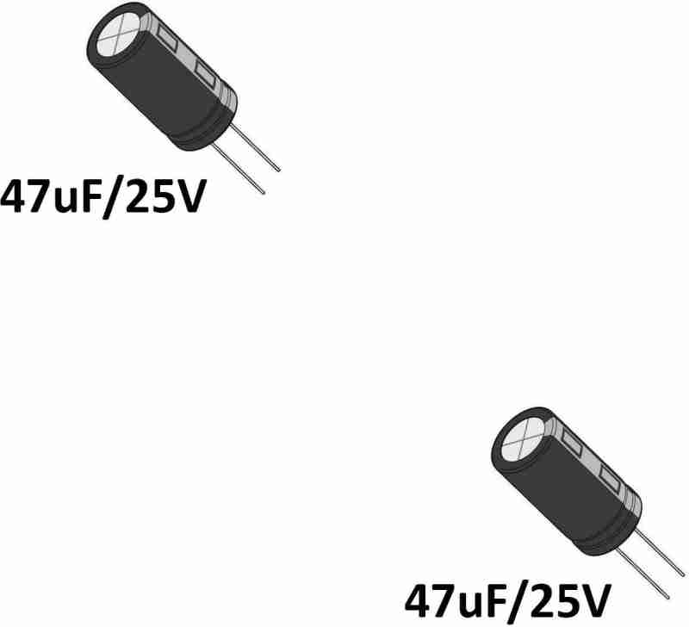

- .

Resistor: A resistor is a device that can limit the flow of electric current. We used various resistors in our circuit to control the voltage and current levels, and to protect the components from damage.
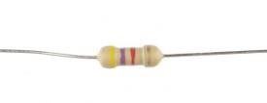

- Bulb: A bulb is a device that can produce light when an electric current passes through a filament. We used a bulb as the load that we wanted to control with our clap switch circuit.

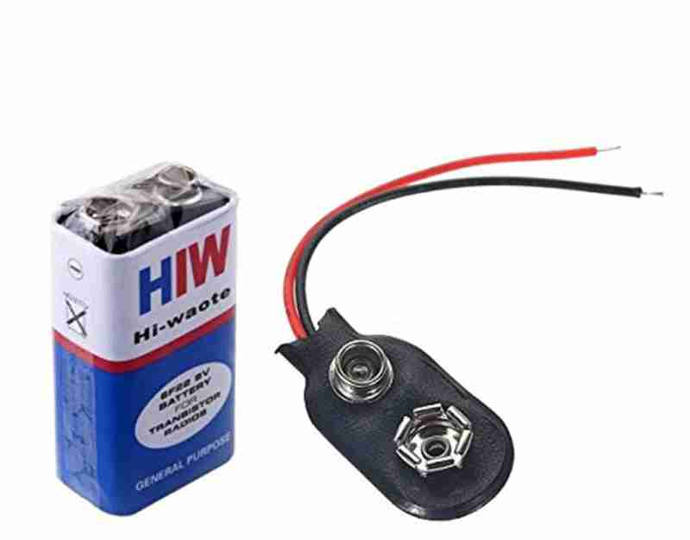
- 9V battery powers the clap switch circuit, providing the necessary voltage for operation.It supplies energy to the circuit components, enabling the clap switch to function correctly

Chapter 6: Circuit Diagram

6.1 Circuit

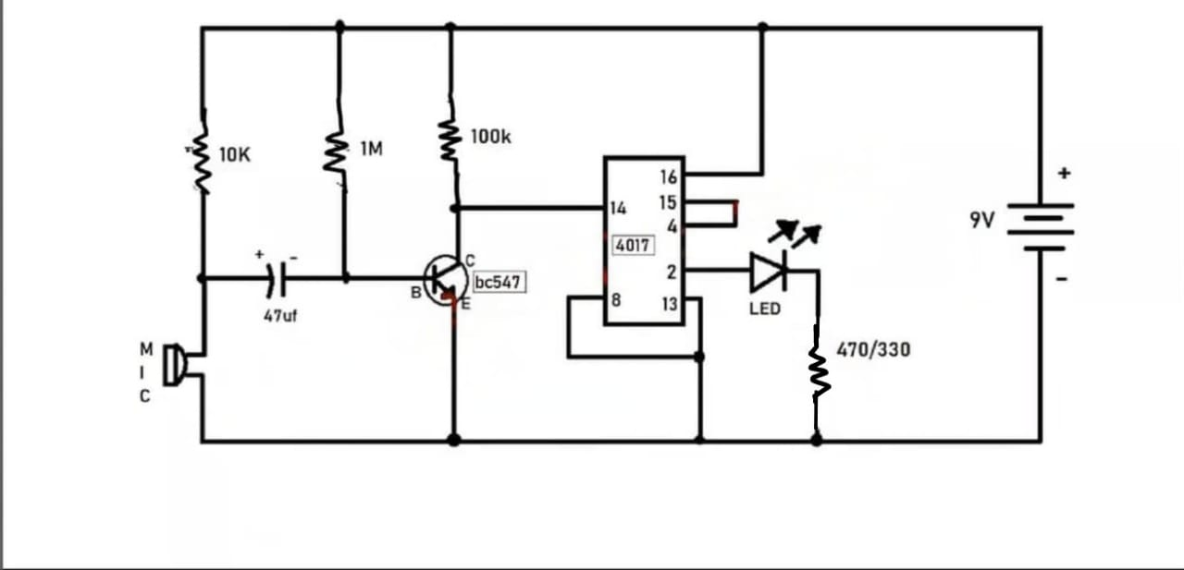

CHAPTER 7
RESULT AND DISCUSSION

The Clap Switch On/Off Circuit was successfully built and tested on a 3.5 x 6 cm PCB board. The circuit worked as intended, with the LED toggling ON and OFF in response to claps. The microphone detected the clap sound, and the BC547 transistor amplified the signal to trigger the IC 4017.

The design was compact, cost-effective, and reliable, though it occasionally responded to other loud sounds. Adjusting resistor values or adding noise filters could improve sensitivity and accuracy. The circuit is practical for small automation tasks and serves as a great project for learning basic electronics

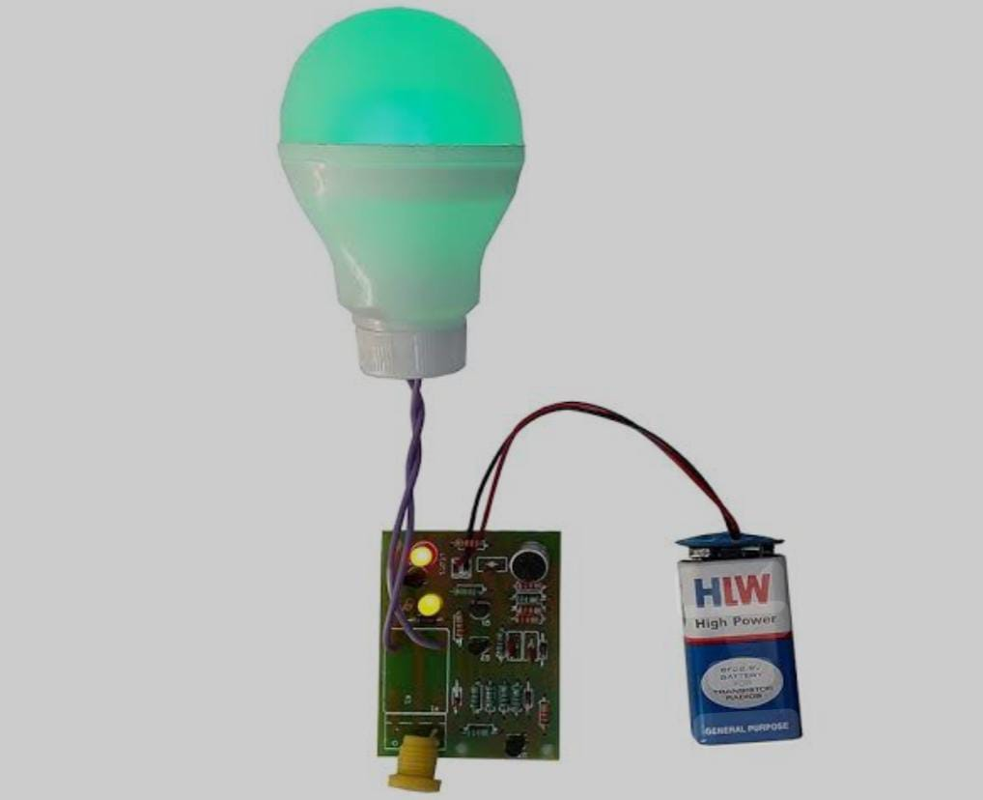

7.1 Overview of the Implemented System
A clap switch circuit is a simple and innovative system designed to control devices, such as turning an LED on and off, using sound signals like claps. This project uses a compact PCB board measuring 3.5 × 6 cm and essential components such as IC 4017, transistors, and resistors to achieve functionality. The circuit begins with a microphone (MIC) that detects sound signals and converts them into weak electrical signals. These signals are then amplified by BC547/BC548 transistors, making them strong enough to be processed by the circuit.

The amplified signals are fed into the IC 4017, a decade counter. This IC toggles between its outputs with each pulse, enabling the LED to turn on or off with every distinct clap. The entire system is powered by a 9V battery connected through a battery connector, and decoupling capacitors are used to stabilize the power supply. The components are soldered onto a PCB board, ensuring the circuit is compact, reliable, and efficient.

7.2 Experimental Results
The circuit successfully toggles the LED with each clap sound. It showed excellent response time, reacting immediately to a single, distinct clap. The LED alternated between its on and off states consistently without delay. The power consumption was low, making the system suitable for battery operation. Furthermore, the circuit worked reliably in environments with controlled noise, highlighting its efficiency in detecting specific sound patterns like claps.

7.3 Challenges Encountered

Several challenges were faced during the implementation of the circuit. Noise sensitivity was a primary issue, as the microphone sometimes detected background sounds, leading to false triggering. This was mitigated by adjusting the sensitivity through resistor value tuning. Another challenge was maintaining power supply stability, as the 9V battery occasionally experienced voltage drops under load. Adding a decoupling capacitor near the IC resolved this issue by stabilizing the voltage.

7.4 Future Enhancements
The clap switch circuit can be enhanced by enabling multi-device control using additional outputs of the IC 4017 and introducing adjustable sensitivity with a potentiometer for better noise rejection. Power efficiency can be improved by incorporating low-power components and a rechargeable battery. Features like clap pattern recognition using a microcontroller, wireless control via Bluetooth or Wi-Fi, and enhanced noise filtering with capacitors or low-pass filters can increase functionality. A compact design with surface-mount components and expanded power options, such as USB or wall adapters, would make the circuit more versatile and user-friendly.
The clap switch circuit can be improved by adding multi-device control, adjustable sensitivity, and power-saving features to enhance efficiency and usability. Advanced functionalities like clap pattern recognition, wireless control, and enhanced noise filtering can significantly increase the circuit's versatility. Compact designs with surface-mount components and flexible power supply options such as USB or wall adapters would further refine its practicality for everyday applications.

7.5 Conclusion

The clap switch circuit demonstrates an effective way to control devices using sound signals. By overcoming challenges like noise sensitivity and space constraints, the project successfully delivered a compact and functional design. This implementation highlights the potential of simple electronic systems in achieving practical and innovative solutions
The clap switch circuit is a simple yet effective system that demonstrates the potential of sound-controlled automation. By implementing the proposed enhancements, the circuit can evolve into a more robust, efficient, and versatile solution suitable for various smart home and automation applications. These improvements would not only enhance its functionality but also make it more user-friendly and adaptable to modern needs

Chapter 8 Application

In this chapter, we discuss the possible applications and benefits of our clap switch circuit. We also suggest some improvements and extensions for our design.

8.1 Applications and Benefits
Our clap switch circuit can be used to control various electrical appliances by clapping, without using physical switches. This can provide convenience, comfort, and safety for the users, especially for people with mobility impairments or disabilities. Some of the potential applications and benefits of our clap switch circuit are:
- Home Automation: Our clap switch circuit can be used to automate the lighting in our home. For example, we can clap to turn on or off the lights in our bedroom, living room, kitchen, or bathroom. This can save energy, reduce electricity bills, and create a comfortable ambiance.
- Security System: Our clap switch circuit can be used to trigger an alarm or a camera when a loud sound is detected. For example, we can clap to activate a siren or a flashlight to scare away intruders or animals. This can enhance the security and safety of our home.
- Sound-Activated Toys: Our clap switch circuit can be used to create soundactivated toys or games for children or adults. For example, we can clap to make a toy car move, a doll talk, or a puzzle solve. This can stimulate creativity, curiosity, and fun.

8.2 Improvements and Extensions
The clap switch circuit can be improved by adding multi-device control using more IC 4017 outputs and incorporating clap pattern recognition with a microcontroller for advanced functionality. Sensitivity adjustment with a potentiometer and enhanced noise filtering can improve reliability in noisy environments. Wireless integration via Bluetooth or Wi-Fi would enable remote control, while a rechargeable battery with USB charging can enhance power options. Compact designs using surface-mount components and feedback mechanisms like LEDs or buzzers would improve usability, making the circuit more efficient, versatile, and suitable for modern automation needs
1. Multi-Device Control:
- Enhance the circuit to control multiple devices by utilizing more outputs of the IC 4017. Each output can be programmed to toggle different appliances with specific clap patterns.

Chapter 9

Advantages and Disadvantages

.1 Advantages
Our clap switch circuit has several advantages over conventional switches, such as:
- Convenience: Our clap switch circuit allows us to control electrical appliances by clapping, without using physical switches. This can save time and effort, and provide comfort and ease of use.
- Accessibility: Our clap switch circuit can be helpful for people with mobility impairments or disabilities, who may find it difficult to reach or operate physical switches. Our clap switch circuit can enable them to control appliances by clapping, which can improve their quality of life and independence.
- Cost-effectiveness: Our clap switch circuit is simple, low cost, and easy to modify. We used discrete components that are readily available and inexpensive, and we assembled them on a breadboard without soldering. We can also change the values of the components to adjust the sensitivity and frequency range of the microphone, the duration of the output pulse, and the base current of the transistor.
- Versatility: Our clap switch circuit can be used to control various electrical appliances, such as lights, fans, TVs, etc. by clapping. We can also use different output pins of the IC 4017 to create different clap patterns and sequences, such as one clap for on, two claps for off, three claps for dim, etc.

9.2 Disadvantages
Our clap switch circuit also has some disadvantages and limitations, such as:
- Noise: Our clap switch circuit may pick up other sounds besides claps, such as coughs, knocks, or speech, and cause false triggering or misoperation. Our clap switch circuit may also produce noise or distortion to the signal, and affect the accuracy and stability of the clap detection.
- Power: Our clap switch circuit may consume a lot of power, generate heat and noise, and wear out over time. We used a relay to switch the load on or off, which may consume a lot of power, generate heat and noise, and wear out over time. We also used a battery to power our circuit and the relay coil, which may run out of charge and need to be replaced.
- Functionality: Our clap switch circuit may not be able to distinguish between single and multiple claps, or different clap patterns, and limit the functionality and flexibility of the device. We used IC 4017 as a clap detector, which can only toggle the output state for each clap sound. .

Chapter 10

Social Impact
Social Impact of the Clap Switch Circuit

The clap switch circuit has a significant social impact as it enhances accessibility, promotes energy efficiency, and contributes to technological awareness. By enabling hands-free operation of devices, it provides convenience and independence, particularly for individuals with mobility challenges, the elderly, or those with disabilities. It reduces reliance on physical switches, making it a user-friendly solution for various environments.

Additionally, the circuit promotes energy conservation by ensuring devices are only operated when necessary, aligning with sustainable living practices. It is an affordable and practical automation tool that democratizes access to smart technology, especially in low-resource settings. Moreover, its simplicity makes it an excellent educational tool, inspiring students and enthusiasts to explore electronics and automation, fostering innovation and skill development.

Overall, the clap switch circuit is a step towards inclusive, energy-efficient, and technologically empowered communities.

Chapter 12
CONCLUSION In conclusion, our Clap Switch project successfully demonstrated the practical application of basic electronic components to create a functional and responsive switching system. Despite the absence of a microcontroller, we leveraged a combination of essential elements, including a Breadboard, Microphone, IC 4017, Transistor, Capacitor, 5V relay, 5V battery, LED, Resistor, Diode, and Bulb, to achieve our desired outcome.

Throughout the project, we encountered challenges and gained valuable insights into the world of electronics and circuit design. The utilization of the IC 4017 proved crucial in implementing a sequential switching mechanism triggered by sound signals from the microphone. The integration of the transistor, capacitor, and relay facilitated the effective control and activation of the connected devices, such as the LED and Bulb, in response to clapping sounds.

One noteworthy aspect of our project is its simplicity and accessibility, showcasing that sophisticated microcontroller are not always necessary for creating functional electronic systems. This approach makes the project not only educational but also cost-effective, allowing enthusiasts and beginners to delve into electronics without the need for complex programming skills.

The collaborative effort involved in assembling and fine-tuning the circuit fostered a deeper understanding of teamwork and problem-solving. We encountered and overcame issues related to component compatibility, signal amplification, and power distribution, which enriched our practical knowledge in troubleshooting electronic circuits.

While our Clap Switch project serves as an engaging educational tool, it also underscores the importance of foundational knowledge in electronics. This experience highlighted the significance of concepts such as signal processing, component specifications, and circuit analysis, providing a solid foundation for future endeavors in the field.

In essence, this project not only fulfilled its primary objective of creating a clapactivated switch but also served as a stepping stone for further exploration and learning in the vast realm of electronics. As we reflect on the journey of conceptualization, design, and implementation, we recognize the invaluable lessons gained and look forward to applying this knowledge in future projects and endeavors.

